City considers ban on pavement product possibly linked to water pollution
By Brendan Gibbons
January 12, 2016 Updated: January 12, 2016 8:35pm
San Antonio could soon join Austin and other state and local governments in banning a paving product federal scientists have said can pose a risk to human health and the environment.
Staff members from the city’s Office of Sustainability and the city manager’s office on Wednesday will brief some City Council members on the economic and environmental effects of coal-tar sealant bans in other regions.
Studies by U.S. Geological Survey scientists and others have identified high concentrations of polycyclic aromatic hydrocarbons — byproducts of burning organic material such as coal, wood, oil, gasoline and even meat — in the shiny, black, coal-based goop sprayed or spread on asphalt to repair cracks.
San Antonio’s ban would, in theory, protect the underlying Edwards Aquifer from slow contamination by runoff from paved surfaces.
District 8 Councilman Ron Nirenberg is taking the lead on the City Council’s consideration of a ban, first drafting a council consideration request in November 2014 with signatures from District 10 Councilman Mike Gallagher, District 4 Councilman Rey Saldaña, District 5 Councilwoman Shirley Gonzales and District 6 Councilman Ray Lopez.
“I had this issue waiting on my desk the first day in office,” Nirenberg said. “Advocates for … water security had been calling for this for quite some time.”
The city’s Citizen’s Environmental Advisory Committee recommended a ban in a June 2014 letter to the council, citing research by federal and state governments and Baylor University.
Austin was the first government in the U.S. to ban coal-tar sealants after a 2005 city-sponsored study found concentrations of polycyclic aromatic hydrocarbons in city creeks.
In a follow-up study published in 2014, USGS scientists found levels of the chemicals in downtown Austin’s Lady Bird Lake decreased in the years after the ban.
The states of Washington and Minnesota, counties in Wisconsin and New York and multiple cities have since banned the product. The Edwards Aquifer Authority also banned its use on pavement near Comal Springs and San Marcos Springs.
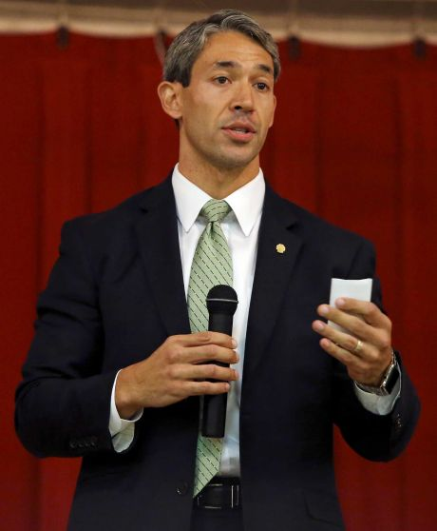
Photo: Edward A. Ornelas /San Antonio Express-News

- 2

District 8 Councilman Ron Nirenberg and Councilman Rey Saldaña, not pictured, want to create a request that the council vote to strip itself of the authority to grant any ethics waivers “desired by a city employee, official or candidate.”

“I think it has minimal economic impact,” Nirenberg said. “Alternatives to coal-tar sealants are widely available and widely used in other jurisdictions. The upside for public health and the quality of our water supply is too great to ignore.”
The pavement industry has challenged the science behind the bans, with the Pavement Coatings Technology Council taking the lead. The council has 20 members, all U.S. or Canadian sealant manufacturers or contractors who use the products, executive director Anne LeHuray said.
Scientists hired by the council published a rebuttal to the USGS’s Lady Bird Lake study in the peer-reviewed Environmental Science & Technology journal. Their paper stated that chemical levels in the lake’s sediment were declining before Austin’s ban and that the chemical signature they more closely matched were general parking lot and street dust than the sealant itself, among other issues.
“The question that San Antonio should ask itself is what is their goal here?” LeHuray said. “These bans have not proven successful, although the USGS has tried to make the case that it’s been successful in Austin. I don’t think they’ve made that case.”
City staff will make their presentation at a Transportation, Technology and Utilities Committee meeting. According to a schedule from the city’s sustainability office, an ordinance banning the product could be introduced by April, with enforcement beginning in November.
bgibbons@express-news.net
@bgibbs on Twitter
Comment from Tom Ennis
Councilman Nirenberg should be applauded for pushing this forward. BTW in the last ten years, Austin's ban has prevented millions of pounds of human carcinogens from entering its environment. The benefits, though difficult to measure, are real.
We encourage the City staff to broaden the stakeholders listed on their schedule. Environmental and public health groups are stakeholders in this process too, yet none are included. Neither is the USGS, who authored many studies and is just up the road in Austin. And of course you haven't included Coal Tar Free America, a source for news and information about coal tar bans across the country.

